

Agency Communication:
October 2025
Promotional Information

Agency communication

Is it challenging for your agency to obtain adequate information on Academy offerings and encourage staff to participate in Learning and Development (L&D) opportunities?
The APS Academy is supporting your agency by sharing information on whole-of-APS L&D initiatives to assist with improving workforce capability. We have created a package of information that can be used by L&D teams to communicate Academy offerings that are available to staff over the coming month. It can be selectively used to promote the Academy and its offerings to increase staff awareness of and participation in learning and development offerings.
Scroll down to find out more about:
- October events & courses
- Academy News
- Intranet/TV Tiles
- MyAcademy newsletter
You will find promotional assets included, in the accompanying folder, to assist in promoting these initiatives at your agency.
More information on events and courses each month are available on the Academy website or Course calendar.



Spotlight on AI

GovAI is a whole-of-government service designed to uplift AI capability, enable efficient ways of working, and enhance productivity across all APS agencies. Services include learning resources, an AI app catalogue, peer-to-peer collaboration tools and a secure sandbox environment for testing and experimentation. GovAI enables responsible and ethical AI use, all within a secure, trusted APS environment. You can also view GovAI and all its offerings.
Lunch and Learns – Artificial Intelligence
Recordings of Session 1, 2 and 3: AI literacy and basics | AI for Personal Efficiency | Find the right policy content with AI

AI in Government and AI's role in capability and learning
23 September 1-2PM
This timely discussion will delve into how AI technologies can be leveraged to enhance of government operations, improve service delivery, and foster innovation in policy formation.

Session 6: Make audio archives searchable with AI
24 September | 12:30PM - 1PM
This session demonstrates how AI can unlock access to historical audio content, support research workflows, and improve discoverability across large collections, even when dealing with complex or multilingual recordings.

Session 7: Building an advanced AI chatbot with your own data
1 Oct 2025 | 12:30PM - 1PM
The Department of Veterans' Affairs (DVA) has developed a new AI-powered chatbot named Poppy, designed to assist staff in efficiently searching and navigating information available on their CLIK website.
Session 8: Test if your AI is ready for real work
8 Oct 2025 | 12:30PM - 1PM
Find out how the Australian Prudential Regulation Authority (APRA) is evaluating generative AI tools for operational use.
Session 10: Accelerate software development with AI
22 Oct 2025 | 12:30PM - 1PM
With access to a wide range of large language models, we can align AI capabilities with specific use cases, from code generation and automation to quality assurance and design research.
The Australian Digital Health Agency continues to expand its software engineering and data modelling capabilities, using AI as a strategic enabler of speed, quality, and innovation.

Session 11: Turn plain text into coded data using AI
29 Oct 2025 | 12:30PM - 1:00PM
The new API based coding capability developed by the ABS makes coding textual data to ABS structured classifications easier, faster and cheaper. Using ML trained models, the Coding Service uses cloud compute for power and scale to achieve highly automated, high-quality coding.

The APS Academy and GovAI are jointly presenting a series of events and providing resources to assist Australian public servants in better understanding Artificial Intelligence. Check out the APS Academy’s helpful AI learning materials on the website.

Further your AI training

 | AI in Government Fundamentals  Foundational training suitable for all public servants. Designed to provide the basics of AI literacy and build confidence in using AI responsible, and in line with official APS AI policy. This course equips you to be:  - ​informed on the applications and risks of AI  - ​capable of applying relevant advice  - ​confident about when it's suitable to use generative AI  - ​empowered to apply your own judgement with AI.
Practical AI for Policy People - Luma
For policy analysts in government to understand the essentials of AI so that they can effectively use it to improve their workflow processes as it pertains to specific tasks. [Category: Government]

The AI Advantage: Fundamentals for Government and Business
A more practical take on AI for public servants. This course provides attendees with the opportunity to enhance their work with real world uses of AI: speeding up routine tasks, reducing errors in reports and documents, improving services, and many more. [Category: Academic]

AI Essentials for Public Sector Workers: Theory to Practice
This hands-on learning experience aims to increase the skill of public servants in applying AI to work process, focused on immediate workplace applications, and compliance with APS guidelines. [Category: Commercial]

AI Governance Professional (AIGP) – IAPP Certification
This course is pitched as developing the skills needed for a new class of AI policy professionals, who will be able to take the lead on AI policies within government and think strategically about AI. [Category: Commercial]

AI+ Government
Aimed at giving public officials a practical primer in leveraging AI in government: improving decision-making and service delivery, while also navigating public sector constraints. Emphasis on building capability and enhance productivity and creativity through the use of AI. [Category: Commercial]

ChatGPT for Government Use: Communication, Analysis, and Productivity
The primary aim of this course is to boost productivity and writing efficiency in the public sector by harnessing generative AI. Practical outcomes, such as clearer communications and faster information synthesis for staff with little or no AI experience. [Category: Commercial]

Upcoming MasterCraft Series events
MasterCraft Series events are virtual workshops facilitated by subject matter experts that deep dive into a topic relevant to the APS Craft or an APS Profession. Events last between 60 minutes and 3 hours.

Buying better and consultancy value for money
30 Sep 2025 | 1:00PM - 12:00PM
This presentation by Australian Government Consulting (AGC) will feature guidance on how to derive greater value for money from the work of consultancies for APS agencies.

AI for Policy People
15 Oct 2025 | 10:00AM - 12:00PM
This workshop provides a foundational understanding of how to prompt engineer to get the best results out of generative AI tools, and demonstrates an extensive array of real work use-case examples to seed ideas about how these tools can be leveraged in your own work context.

Navigating Australia’s Foreign Policy in the Indo-Pacific
28 Oct 2025 | 1:00PM - 2:00PM
This event will provide APS professionals with a strategic overview of Australia’s foreign policy in the Indo-Pacific—an increasingly complex and contested region.

Institute of Public Administration Australia latest events and programs
Secretary Series: Rob Heferen, Commissioner of Taxation 1 October 2025 | 9:30AM - 11:40AM
Learn from one of Australia’s eminent public service leaders, Rob Heferen - Australia’s 13th Commissioner of Taxation, leading the Australian Taxation Office (ATO). In this keynote address and Q&A, he will talk about his experience leading one of Australia’s most trusted public sector agencies, what got him to where he is today, and what the ATO priorities are for the coming years.
Spirit of Service Awards gala dinner | 22 October 2025 | 6:00PM - 9:30PM
These awards honour public sector initiatives that deliver meaningful, positive change for the Australian community. Through this celebration, we shine a spotlight on outstanding achievements, share valuable insights across the sector, and elevate the profile of the agencies driving innovation and impact. Meet the 2025 Spirit of Service Awards finalists here.

New course spotlight
6R Relational Leadership Capabilities Skills Lab
Leaders who have the skills to foster and maintain meaningful relationships that inspire, empower and support others drive organisational success, as well as psychological and psychosocial safety within their teams. It’s not just about achieving outcomes, it is about how we achieve them, by building trust, accountability and ensuring people feel heard, valued and empowered.

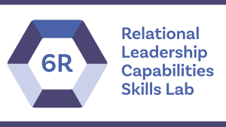
Upcoming dates:
- 9 October
- 4 November

This program involves an interactive skills lab and mentoring session that equips leaders with the relational skills embedded in the 6R framework to foster pro-integrity, stewardship, psychosocial safety, and high performance.

Upcoming courses
Upcoming mixed agency courses of interest available through APSLearn.
Courses | Date
EL2 Data Leadership | 1/10/2025
Managing Remote and Hybrid Teams | 2/10/2025
6R Relational Leadership Capabilities Skills Lab | 9/10/2025
Dealing with Change | 13/10/2025
Workforce Planning Start Up Program | 16/10/2025
Conflict Resolution for Employees | 23/10/2025
Briefing and Responding to APS Decision Makers | 23/10/2025
Working Effectively at the APS 6 Level | 29/10/2025
Delivering Great Policy - Foundations | 3/11/2025
Report Writing in the APS | 5/11/2025
Leading Successful Projects | 5/11/2025
Understanding Government | 11/11/2025
Building Relationships and Engagement | 12/11/2025
Building and Leading High Performing Teams | 13/11/2025

Interstate mixed agency deliveries
Effective Communications | Melbourne | 25-26 /11/2025
Building and Leading High Performing Teams | Adelaide | 18/3/2026
Building Relationships and Engagement | Adelaide | 19/3/2026
Delivering Great Policy – Foundations | Sydney | 19-20 /6/2026

APSLearn course updates
Net Zero Procurement | New eLearn | 9 Sept | This course is part of the Climate Action in Government Operations program.
Commercial Negotiation | New eLearn | 2 Sept | This course is part of the Procurement and Contract Management Training Suite.
​Procurement Risk Management | New eLearn | 20 Aug | This course is part of the Procurement and Contract Management Training Suite.
6R Relational Leadership Capabilities Skills Lab | New workshop | 20 Aug | This program involves an interactive skills lab and mentoring session that equips leaders with the relational skills embedded in the 6R framework to foster pro-integrity, stewardship, psychosocial safety, and high performance.
Compassionate Foundations: Suicide prevention capability suite | Updated course | 18 Aug | This content has been provided by the APS Mental Health and Suicide Prevention Unit, Australian Public Service Commission.

News from the APS Academy

Information for L&D Teams
SES Welcome
There are still places available in the two remaining 2025 SES Welcome program cohorts! Welcome is designed to introduce the expectations and obligations of SES roles and provides an opportunity to connect with peers and colleagues across Australia. In addition to hearing from the most senior members of the SES they are also provided the opportunity to chart a course for their first 6 months in the SES. Register for this free program.

Upcoming sessions (Virtual via MS Teams):
- Friday 19 September, 10am – 12:30pm
- Friday 28 November, 2 – 4:30pm

SES Band 2 Leadership Program
Stay tuned - new SES Band 2 program dates will be announced soon! Send your expressions of interest to the team.

2026 Program Dates
The Academy’s Executive Programs team are in the process of teeing up 2026 program dates, and are likely to communicate them with SES Unit and L&D teams in mid-November. If you would like to discuss your agency’s requirements or to add to our waitlist for 2026, feel free to reach out to the Leadership team with any queries.

Jawun APS Secondment Program, Round 1, 2026 nominations due 13 November 2025
Are you ready to raise your awareness of the cultural diversity of Indigenous Australia while developing new professional and personal skills, confidence and resilience? Are you keen to bring your learning back to your agency and community to influence the broader system to achieve better outcomes for all citizens? Importantly, your experiences on a Jawun secondment will help equip you as part of a growing alumni to proactively contribute to the long term transformation of government organisations, as part of the Commonwealth’s commitment to the National Agreement on Closing the Gap Priority Reform 3.

The Jawun APS Secondment Program offers standard (6-week) secondments to substantive high-performing and high-potential APS 6 and above employees, who are flexible, resilient and prepared to be taken out of their comfort zone. Opportunities also exist for high-performing Executive Level 2 or Senior Executive Service (SES) leaders to contribute to longer strategic projects through Empowered Communities secondments. Empowered Communities secondments are 12-week secondments requiring secondees with higher order strategic or operational expertise.

Nominations for Round 1, 2026 are due by Close of Business 13 November. Secondment timeframes and final nomination cut-off dates for 2026 are outlined below.

Agency coordinators can email any nominations.

Secondment Round | Secondment dates | Nomination cut-off date
Round 1 | Between February and March | Thursday, 13 November 2026
Round 2 | Between May and June | Thursday 29 January 2026
Round 3 | Between July and September | Thursday 23 April 2026
Round 4 | Between October and December | Thursday, 10 July 2026

For more information about the program, visit the Jawun APS Secondment Program
For more information about Jawun, visit the Jawun website
Visit the website for more information on Closing the Gap including Priority Reform 3

International Fraud Awareness Week | 15-22 November 2025

The Commonwealth Fraud Prevention Centre is excited to lead Australia’s campaign for International Fraud Awareness Week (IFAW) in November 2025.
Their theme is "Preventing Fraud is a Team Effort – Don’t Sit on the Sidelines."
This is an opportunity for all agencies to raise awareness, strengthen collaboration and highlight that everyone plays a part in preventing fraud.

Promotional toolkit included in the promotional assests pack.

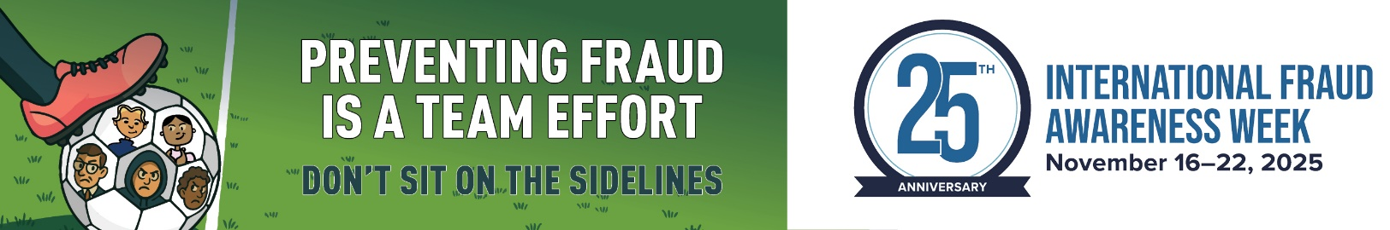

General Information for All Staff
Conflict of Interest Better Practice Model
The Australian Public Service Commission, the Department of Finance and the National Anti-Corruption Commission have collaborated to produce the APS Conflict of Interest Management Framework and supporting resources. These have now been published on the respective agency websites and form part of a whole-of-APS approach to strengthening the declaration and management of conflicts of interest.

Microcredentials for the APS
The APS Academy has partnered with highly esteemed universities, to develop four groundbreaking postgraduate-level microcredentials designed for public servants. Designed by leading APS practitioners and academics, these programs provide high-quality learning tailored to the demands of our APS workforce.

Microcredentials are short industry aligned programs or certifications, delivered by universities and registered training providers, that validate specific skills or knowledge. They offer a flexible, targeted way to enhance skills and advance careers.

Microdentials flyer included in the promotional assests pack.

Stewardship in action: practitioner led-learning​
‘Stewardship’; our commitment to the Australian public to not only serve the government of the day but to build a thriving public service capable of serving generations to come. Our reputation today, and the legacy we leave, matter. Every day, our every action, builds or erodes our reputation as an effective and trusted service and strengthens or diminishes our capability to deliver for the Australian public.
Read the full article on our website.

Intranet / TV tiles

1920 x 1080 pixel (16:9) image
(Copy – The APS Academy has learning opportunities available for all staff. Check out the courses, resources and people networks that you can connect with on your learning pathway. Find out more. (Use this link with tile https://www.apsacademy.gov.au/courses/)

MyAcademy

One other way to stay current is to subscribe to the MyAcademy newsletter. Subscribers are the first to hear about new things happening at the Academy and across the APS!
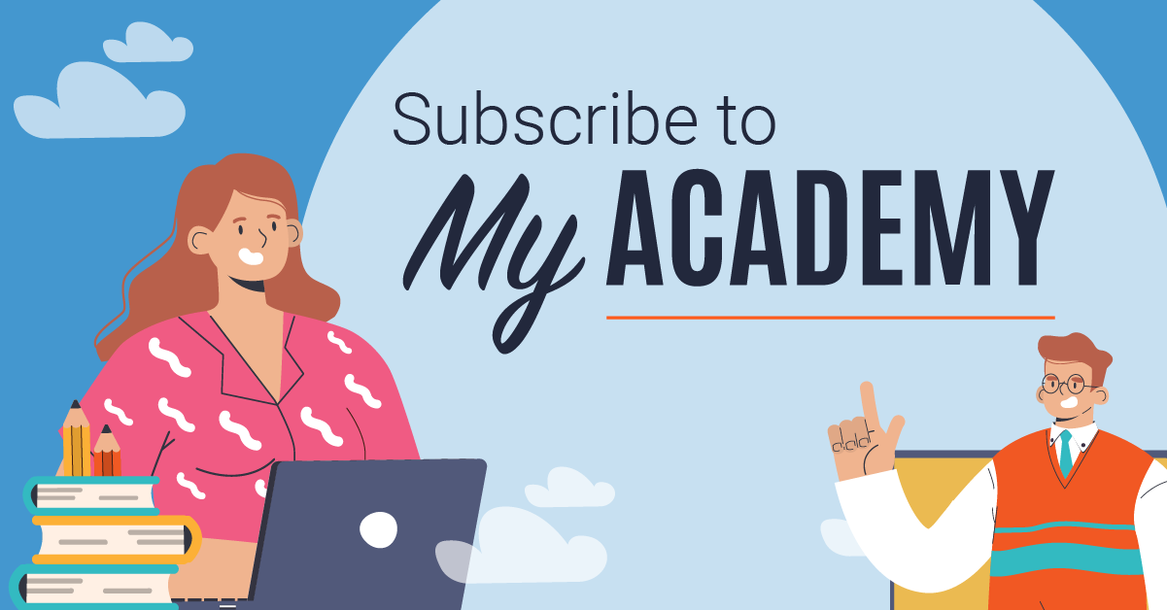

Contact Us

If you have any queries or questions, reach out to your Agency Relationship Manager or the Academy at:

APS Academy Team
e. APSAcademy@apsc.gov.au
p. 02 6202 3933
w. apsacademy.gov.au

Return to top

