

Agency Communication:
January 2025

Promotional Information

Agency communication
Is it challenging for your agency to obtain adequate information on Academy offerings and encourage staff participation in Learning and Development opportunities?
The APS Academy is supporting your agency by sharing information on whole-of-APS L&D initiatives to assist with improving workforce capability. We have created a package of information that can be used by L&D teams to communicate Academy offerings that are available to staff over the coming month. It can be selectively used to promote the Academy and its offerings to increase staff awareness of and participation in learning and development offerings.
Scroll down to find out more about:
- January events & courses
- Academy News
- Intranet/TV Tiles
- MyAcademy newsletter.
You will find promotional assets included, in the accompanying folder, to assist in promoting these initiatives at your agency.
More information on events and courses each month are available on the Academy website or Course calendar or as indicated.

image January Learning Experiences

Events
MasterCraft Series - Infectious Optimism: The 2020s APS Leader's Superpower
20 February 2025
Discover Magnetic Optimism to power leadership, wellbeing and resilience. Inspiring change in families, organisations and communities.

MasterCraft Series - Program Management as a critical APS capability
25 February 2025
This Mastercraft event will take us through the Practice Enhancement Frameworks and understanding what unconscious bias is, how it tends to operate and how we as public policy professionals can minimise its impacts in the way we think and behave.

Face to Face Courses | Date
Delivering Great Policy Foundations - Melbourne | 4 & 5 February 2025
Engaging Stakeholders - Hobart | 25 & 26 March 2025
Face to Screen Courses | Date
Strategic Thinking | 11/02/2025
Briefing and Responding to APS Decision Makers | 18/02/2025
Producing a Quality Cabinet Submission | 21/02/2025
Essential Writing for Executive Levels | 3/03/2025
Building Relationships and Engagement | 4/03/2025
How to Apply for Jobs in the APS - APS Levels | 4/03/2025
Human Centred Design 101 | 5/03/2025
Developing Project Management Expertise | 18/03/2025

News from the APS Academy

Information for L&D Teams

Senior Executive Leadership Programs
SES Integrity Masterclass – Exciting new 2025 updates
Given the speed of change in the APS Integrity ecosystems, it is important the APS Academy learning resources reflect the most up to date thinking. After extensive consultation with APS agencies, SME’s and integrity related academics throughout 2024, the APS Academy is pleased to share that from January 2025, all SES Integrity Masterclass course participants will receive updated (and shorter) pre-work materials, and new case studies to work through in the facilitated workshop.

Some key points for Agency L&D teams to be aware of include:
- The workshops have increased by 30 minutes to 3.5 hours to allow for additional complex case studies to be included.
- Pre-work activities have reduced from approximately 4 hours to approximately 2.5 hours
- From Jan 2025 there will be a new SES Integrity Masterclass entry in the APSLearn, and the 2021-2024 version will be archived.
  - Any automated links to the old version in your own LMS systems will need to be updated. Instructions will be provided in the new year.
  - For your Agency completion rate data reporting, please note you will need to run two reports (one for the old version and one for the new) and collate them to get your overall data. They cannot be merged as the mandatory completion activities for the versions are different.
  - The archived version will still be visible in APSLearn for those participants who need to revisit their original course materials. Those participants do not need to complete the new version.
- Any ‘single agency’ bookings for 2025 will automatically be using these new materials, and have the additional 30 minutes added to the end of the planned session.
- Any participants booked into the ‘mixed agency’ sessions in March and May 2025 will be notified in the new year of the changes and moved to the 2025 version.
Reach out if you have any enquiries.

SES Leadership programs
We are developing the 2025 SES Leadership offerings. The calendar will be available on the APS Academy website and on APSLearn. Please contact the Leadership team to advise your name and details for our EOI register and we will reach out to update you.
If you have any other questions, please do not hesitate to reach out – we are looking forward to seeing your SES at our programs in 2025.

2025 APS Graduate Development opportunities
The APS Academy is seeking agency expressions of interest in whole-of-APS graduate development opportunities for your 2025 graduate intakes. These opportunities provide a range of options tailored to meet your agency or department’s needs, whether you are looking for options to fully meet your graduate development requirements or simply want to supplement your existing development programs.

Interested agencies and departments can choose between full participation in the APS Graduate Development Program or selecting events or coaching only packages.

Key opportunities include:
- APS Graduate Development Program: Commencing in March 2025, the 10-month program includes 10 learning sprints, access to the full suite of Whole of APS Graduate Event Series events and individual coaching sessions.
- Whole of APS Graduate Event Series: Commencing in March 2025, the series brings Graduates together for interactive and informative workshops. The series includes in-person and virtual events and agencies can opt-in for virtual or in person packages, or both.
- Coaching for graduates: Usually reserved for senior executives, coaching packages are a unique and valuable option for providing extra support throughout their Graduate year.

If your agency is interested in the above, please email the Academy’s Graduate Development team with your preferred participation option or we can provide more information as required. You can also visit the APS Academy website.

Taking APS Leadership Edge to the next level
With two successful implementations of our EL2 development program, it is time for us to take APS Leadership Edge further. We want to have even more EL2s developing their capability as leaders and managers, provide greater flexibility to support their development, increase the resources available for EL2s and build a community to provide continued learning and collaboration across the APS.

In 2025, there will be two ways to interact with APS Leadership Edge:
- APS Leadership Edge Community
- APS Leadership Edge Premium.
APS Leadership Edge Community is a low-cost, high-impact social learning experience for EL2s. We know developing communities to allow people to seek advice and learn from each other works (see the APS Professions). We’re going to build this community for EL2s and supercharge it with by including:
- access to masterclasses
- targeted learning opportunities
- developing and sharing EL2 specific resources.
APS Leadership Edge Community will be the place for EL2s to find out the latest information, connect with their peers and develop their leadership capability.

APS Leadership Edge Premium is the current successful program, but we’re enhancing it to provide a better experience. It will include:
- access to the 4 core learning sprints in two different formats, multiple times over the year
- access to choice of additional learning sprints on-demand
- group coaching sessions
- APS Leadership Edge Community access.
With our enhanced delivery for APS Leadership Edge Premium, it will be more flexible and valuable for the participants. Registrations open in January 2025 via APSLearn for individuals. Agencies can bulk register by email. Registration will be open until June 2025. The program will begin in February.

COSTS
APS Leadership Edge Community: $150 per person
APS Leadership Edge Premium: $2,000 per person
Any questions, please contact the team on LeadershipEdge@apsc.gov.au

APSLearn Dashboards and Resources for Agencies
To support agencies in utilising APSLearn effectively, this section highlights key resources available within the platform. Please share this information broadly across your teams and any associated sub-agencies within your portfolio. Key Resources and Links are essential information for APSLearn, APS Partner Content, APS Learning Bank:

Share and reuse learning experiences | Australian Public Service Academy (apsacademy.gov.au)
Onboard learning experiences | Australian Public Service Academy (apsacademy.gov.au)

APSLearn Dashboards
APSLearn offers personalised dashboard accessible from the homepage, tailored to assist with various functionalities. These dashboards are role-specific and include guides for:

- Reporting Officers and cohort managers
- Content Facilitators
- APS Partner Content
- APS Learning Bank

Note: Not all users have access to these dashboards. Access is provided only to those who hold specific roles or have been granted permission by APSLearn administrators.

General Information for All Staff

Short-form learning media survey participants call out
The Australian Centre for Evaluation (ACE) are developing new online content on AI and data for research and evaluation. They are seeking APS participants to survey on which formats tend to be most effective (e-learning modules, videos, podcasts etc). Each participant’s involvement in the trial is likely to be no more than 30 mins.
The attached, What works? Assessing the impact of different online learning methods, document outlines what the commitment is. Interested participants can contact the ACE team for more information.

Join the biggest event of the year
The Digital Profession’s Innovation Month is back in 2025 and are seeking agencies who want to showcase their work or explore new ways of doing things. Did you try something new in your agency? Was there a workshop you hosted that could be shared across the APS?

This is your chance to let the greater community know who you are and what you do or have done with success. This year in July we ran 20 events with over 7,000 attendees, including some senior leadership panels. Contact the Digital Profession team if you would like to get involved.

Performance Management Research Survey – Shannan Quain
As part of the Australian Human Resources Institute (AHRI) Inaugural Scholarship, I am conducting a research survey to better understand the performance management practices within the Australian Public Service (APS). Your insights are crucial for identifying challenges and opportunities for improvement in how performance conversations are conducted, how barriers can be addressed, and how productivity is monitored. It is important that as many voices as possible are heard and your insights will be used to shape a new era of Performance Management in the public service.

Please access the survey and complete your perspective as soon as possible.

Elevate your career with cutting-edge microcredentials: Upskill in critical areas now!
Ready to take your career to the next level?
The APS Academy has partnered with highly esteemed universities, to develop four groundbreaking microcredentials. Designed by leading APS practitioners and academics, these programs provide high-quality learning tailored to the demands of our APS workforce. All four microcredentials are now open to Commonwealth and state and territory public servants.

Secure your spot for a Microcredential in Pacific Engagement through Flinders University
2025 Pacific engagement dates are:
19 Mar 25, 10:00am – 11:00am ADST
2 Apr 25, 10:00am – 11:00am ADST
16 Apr 25, 10:00am – 11:00am AEST
30 Apr 25, 10:00am – 11:00am AEST
14 May 25, 10:00am – 12:00am AEST
28 May 25, 10:00am – 11:00am AEST

Find out more and register your interest in these three other career-boosting microcredentials now.
Foresight techniques, University of New South Wales: enquire here
Gender impact in policy design, University of New South Wales: enquire here
Evaluating regulatory systems, University of Melbourne: enquire here

APS Integrity Hypotheticals event recording now available in APSLearn
During November, the APS Academy and the Department of Industry, Science and Resources (DISR) held an integrity MasterCraft Series event framed around a series of ‘hypothetical’ conflict of scenarios. The “APS Integrity Hypotheticals – Conflict of Interest” event saw three senior public service executives share the integrity spotlight, with each panellist sharing how they would address the ever evolving scenarios posed to them. The event highlighted the grey (and not so grey) areas of decision making and what public servants should consider when confronted with similar positions or how to approach decisions in general with integrity. A key message was that the boundaries of conflicts of interest are rarely straight forward.

An engaged audience from over 90 agencies across the APS were also given the opportunity to ask the panellists questions. We encourage you to share the link to this recording - now available on APSLearn - with your staff so that anyone who missed the live event can still experience this engaging, thought provoking Integrity based learning opportunity.

Practitioner and casual facilitator opportunities now available
The #APSacademy is looking for Australian Public Service practitioners with more than 5 years’ experience in their field of expertise at the EL2 or Band 1 level to support fellow public servants raise their Craft capability skills.

👉 Practitioner micro-assignment opportunities, now live on APS jobs

We are also recruiting for casual facilitators with extensive APS experience to deliver a wide range of subject matter to an APS and SES audience through face to face and virtual course deliveries. Casual facilitators are employed by the APSC and deliver professional development courses to the APS on behalf of the APS Academy.

👉 Casual Facilitator Register is now live on APS Jobs

Finally, we are looking for APS employees with coaching experience and qualifications, who want to make a meaningful impact to APS graduates, whilst enhancing their coaching capability. If this is you, please apply.
This initiative is designed to create sustainable coaching capability uplift across the APS. Since our first micro-assignment in 2023, the APS Academy has engaged and developed 14 APS coaches.

👉 APS Coaches Micro-assignment Register is now live on APS Jobs

Intranet / TV tiles


1920 x 1080 pixel (16:9) image
Copy – The APS Academy has learning opportunities available for all staff. Check out the courses, resources and people networks that you can connect with on your learning pathway. Find out more. (Use this link with tile https://www.apsacademy.gov.au/courses.

MyAcademy
One other way to stay current is to subscribe to the MyAcademy newsletter. Subscribers are the first to hear about new things happening at the Academy and across the APS!

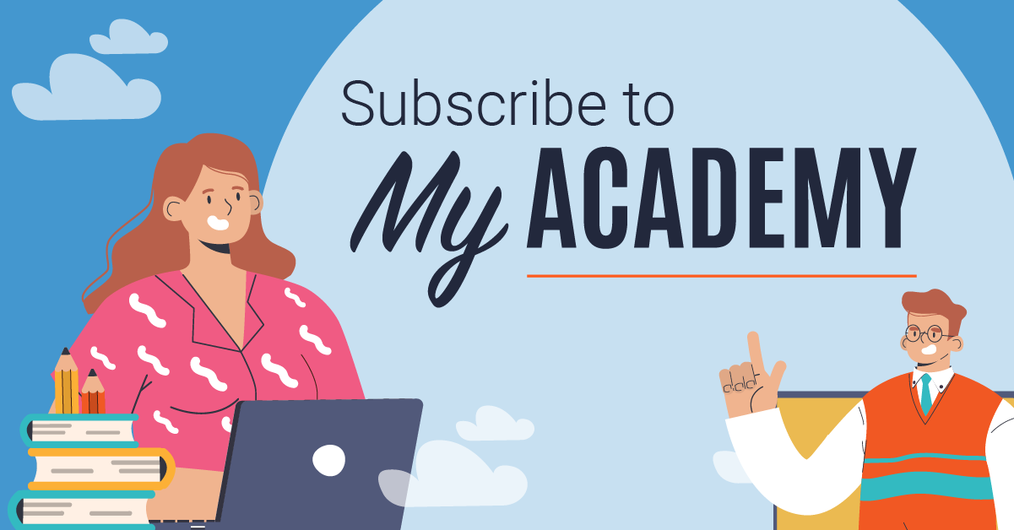

Contact Us
If you have any queries or questions, reach out to your Agency Relationship Manager or the Academy at:
APS Academy Team:
- APSAcademy@apsc.gov.au
- 02 6202 3933
- apsacademy.gov.au.
Return to top

